Name

Mathematics Stage 4
Area of Quadrilaterals

Book 3 |  | Version: 260707  Feedback:  https://MrDingMaths.com
Contents
Syllabus Content 2
Learning Intention 3

Syllabus Content
MA4-ARE-C-01 applies knowledge of area and composite area involving triangles, quadrilaterals and circles to solve problems
Develop and use the formulas to find the area of trapeziums, rhombuses and kites to solve problems
- Develop and apply the formula to find the area of a kite or rhombus: $A=\frac{1}{2}xy$, where $x$ and $y$ are the lengths of the diagonals
- Develop and apply the formula to find the area of a trapezium: $A=\frac{h}{2}\left(a+b\right)$, where ℎ is the perpendicular height and $a$ and $b$ are the lengths of parallel sides
- Calculate the area of composite shapes involving trapeziums, kites and rhombuses to solve problems

Area of Kites and Rhombuses

- Diagonals
Adjacent means next to.
An edge of a shape joins two adjacent vertices.
A diagonal of a shape joins two non-adjacent vertices.
A diagonal goes from one corner to another, skipping at least one corner.
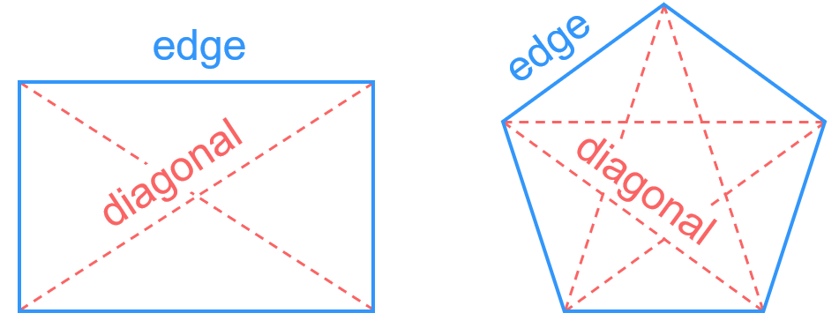

- Identify diagonals
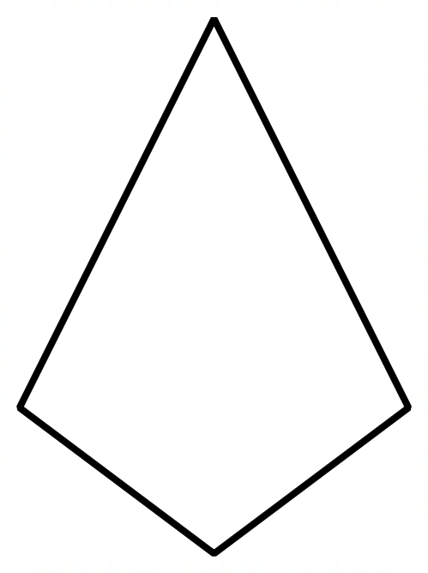

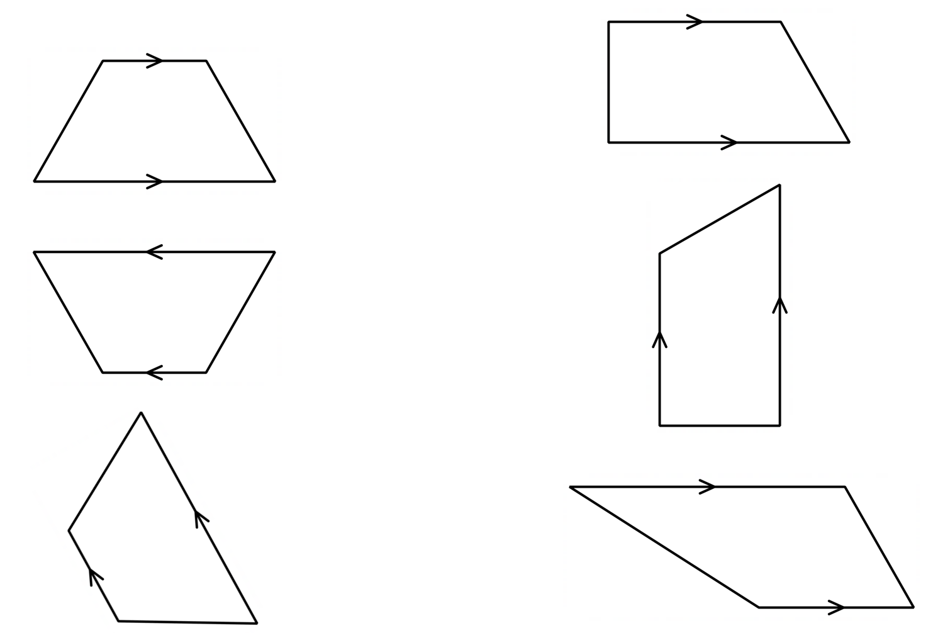

- Kites
A kite is a four-sided shape with two pairs of adjacent sides equal.
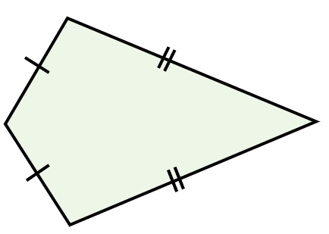

✖  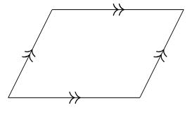 | ✔  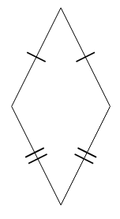 | ✔  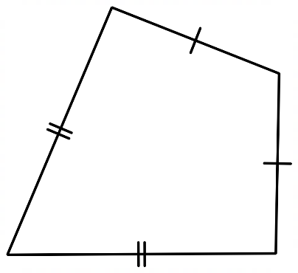 | ✔  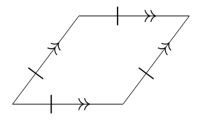 | ✖  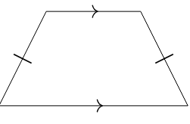

- Rhombuses
A rhombus is a four-sided shape with all four sides equal.
Since the adjacent sides are equal, a rhombus is also a kite.
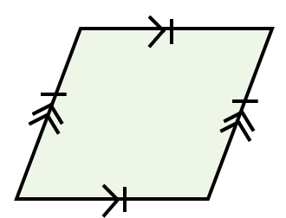
The opposite sides are parallel, so a rhombus is also a parallelogram.

✖  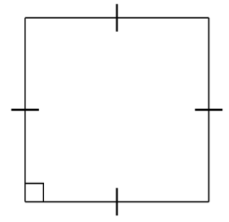  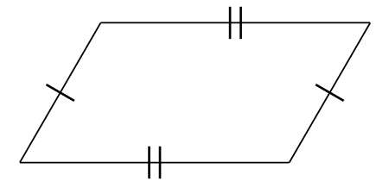 | ✔  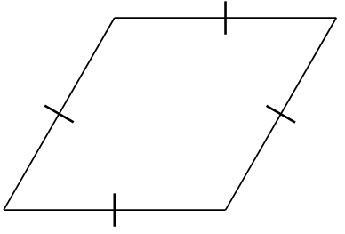 | ✔  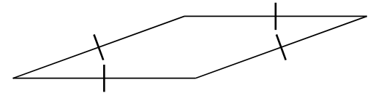 | ✔ | ✖  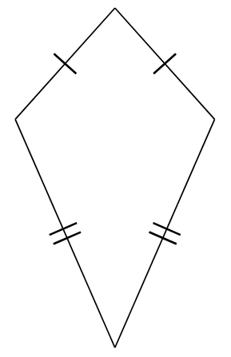

- Investigation area of a kite
- Area of a Kite: https://www.geogebra.org/m/dhdwbyzf

A kite is shown below to the left. The length of the diagonals is given by $x$ and $y$.
Consider the shape to the right. What has happened between the two shapes?
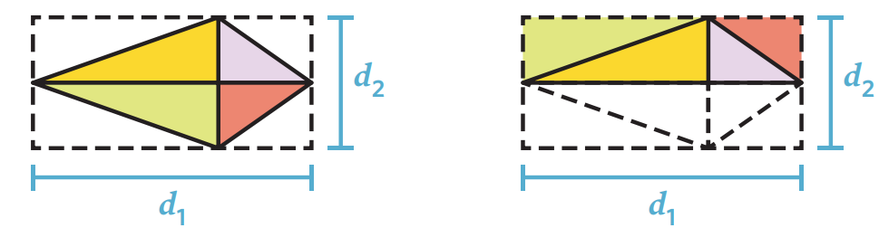
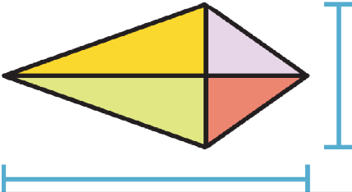
$$x$$
$$y$$
$$x$$
$$y$$

Using the area of a rectangle, write the area for the area of the kite.

A rhombus is a kite and a parallelogram.
The area of a rhombus can be found using either formula, depending on what is given.
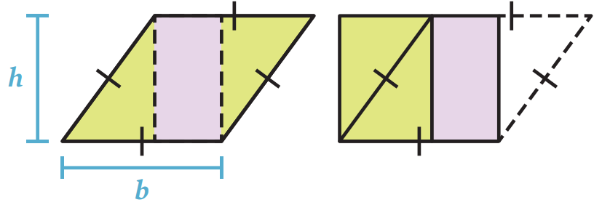  If base and height are given:  $$A=bh$$ | 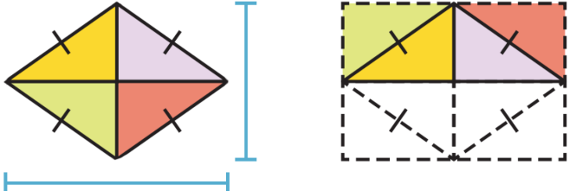  $$x$$  $$y$$  If diagonals are given:  $$A=\frac{xy}{2}$$

Why is a rhombus also a kite?
A rhombus has four equal sides, meaning its …………… sides are equal. So, it’s a kite.

Why is a rhombus also a parallelogram?
A rhombus has two pairs of …………… sides, meaning it’s a parallelogram.

- Area of a Kite and Rhombus
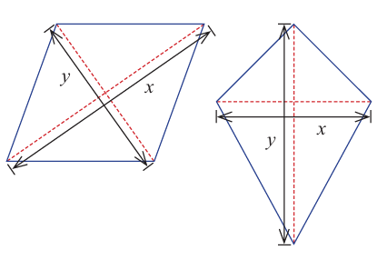

diagonals

$$A=\frac{xy}{2}$$

- Example Calculate area of a kite or rhombus
Calculate the area of these shapes
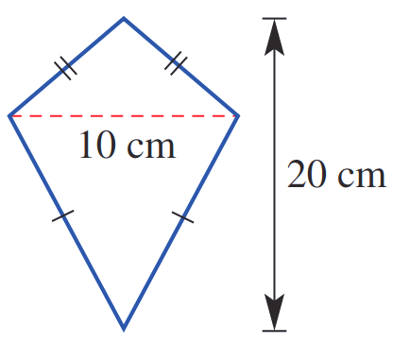  $$A=\frac{xy}{2}$$  $$=\frac{10×20}{2}$$  $=100$ cm² | 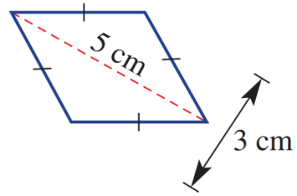  $$A=\frac{xy}{2} \\ =\frac{5×3}{2}$$  $=7.5$ cm²

- Guided Practice
Calculate the area of these shapes.
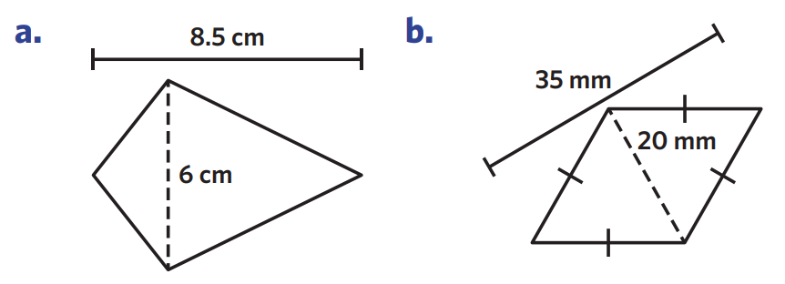  $$A=\frac{xy}{2}$$  $=$ ………………  $=$ ………………  25.5 cm² | $$A=\frac{xy}{2}$$  $=$ ………………  $=$ ………………  350 mm²
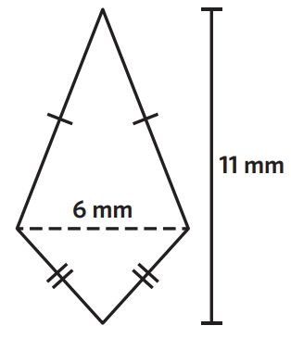  $A=$ ………………  $=$ ………………  $=$ ………………  33 mm² | 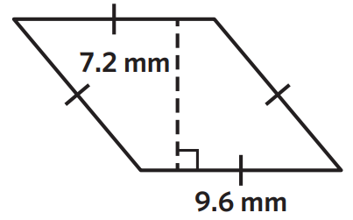  $A=$ ………………  $=$ ………………  $=$ ………………  69.12 mm²

- Identify formula for area
For each quadrilateral, decide which formula you would use to calculate the area.
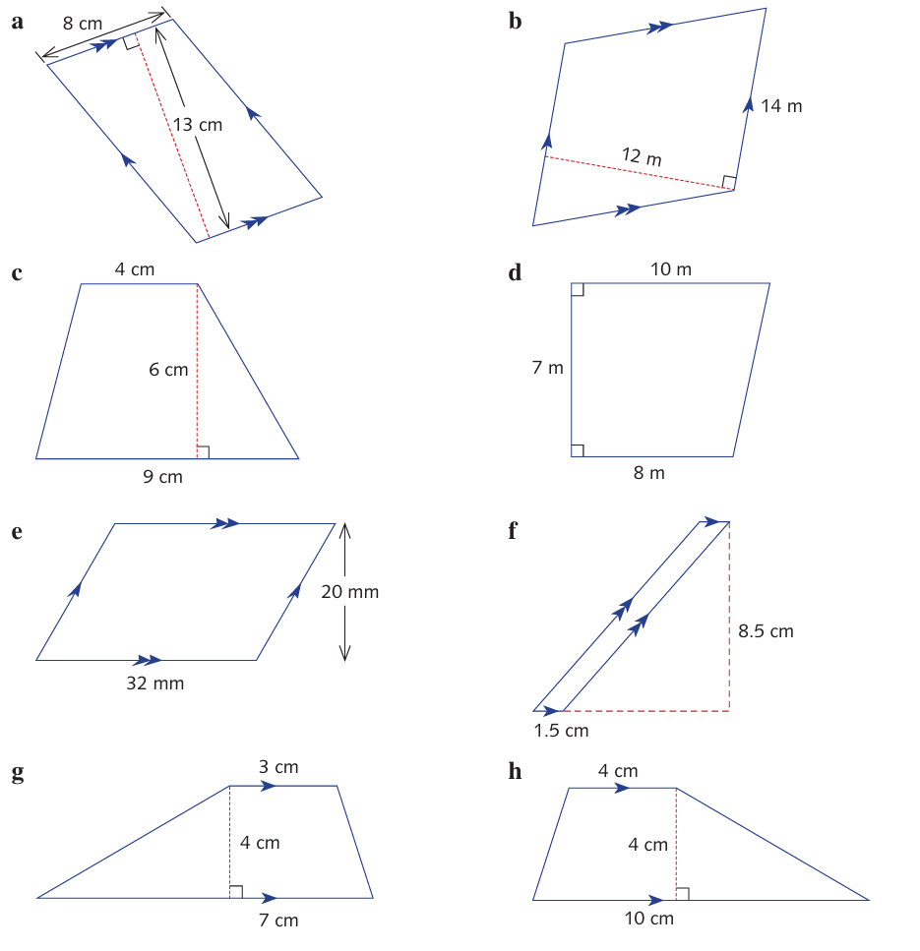  - $A=bh$  - $A=\frac{1}{2}xy$ | - $A=bh$  - $A=\frac{1}{2}xy$ | 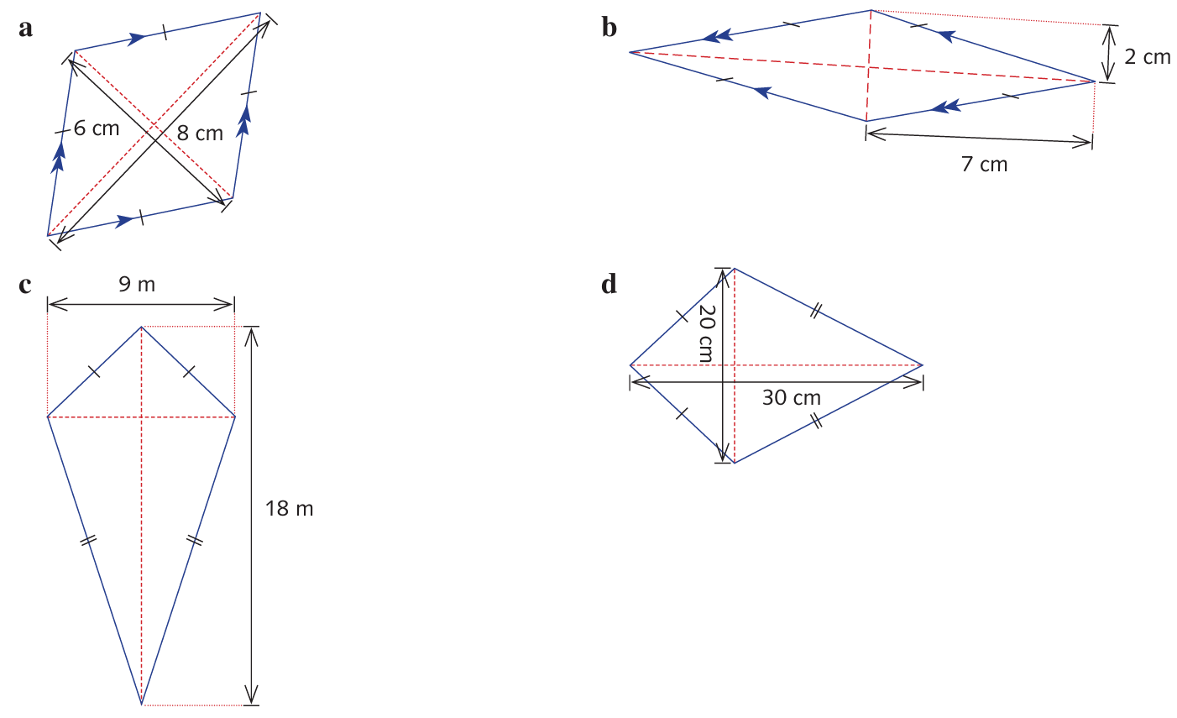  - $A=bh$  - $A=\frac{1}{2}xy$
- $A=bh$  - $A=\frac{1}{2}xy$ | 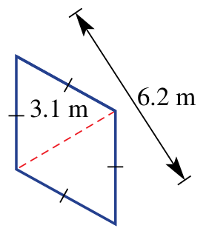  - $A=bh$  - $A=\frac{1}{2}xy$ | - $A=bh$  - $A=\frac{1}{2}xy$
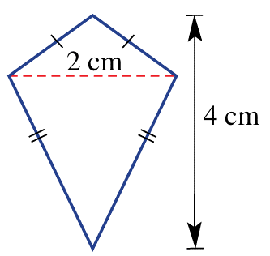  - $A=bh$  - $A=\frac{1}{2}xy$ | - $A=bh$  - $A=\frac{1}{2}xy$ | 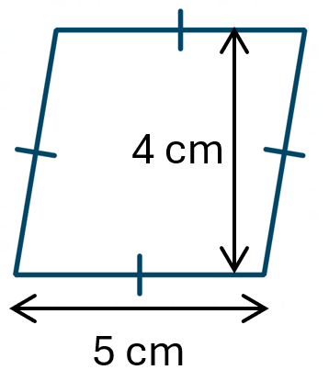  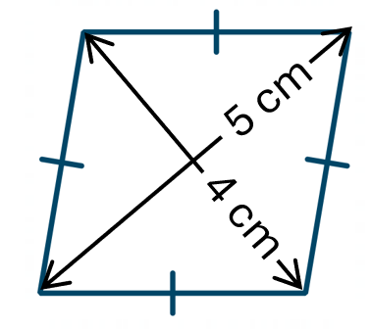  - $A=bh$  - $A=\frac{1}{2}xy$

- Key Ideas
- The area of a kite is half the product of the ………………….…
- A rhombus is also a ……………, so we use the formula $A=bh$ if the base and height are given, and the formula …………… if the diagonals are given.

Foundation
- Calculate the area of these parallelograms, kites, and rhombuses. Round to 2 d.p. if needed.
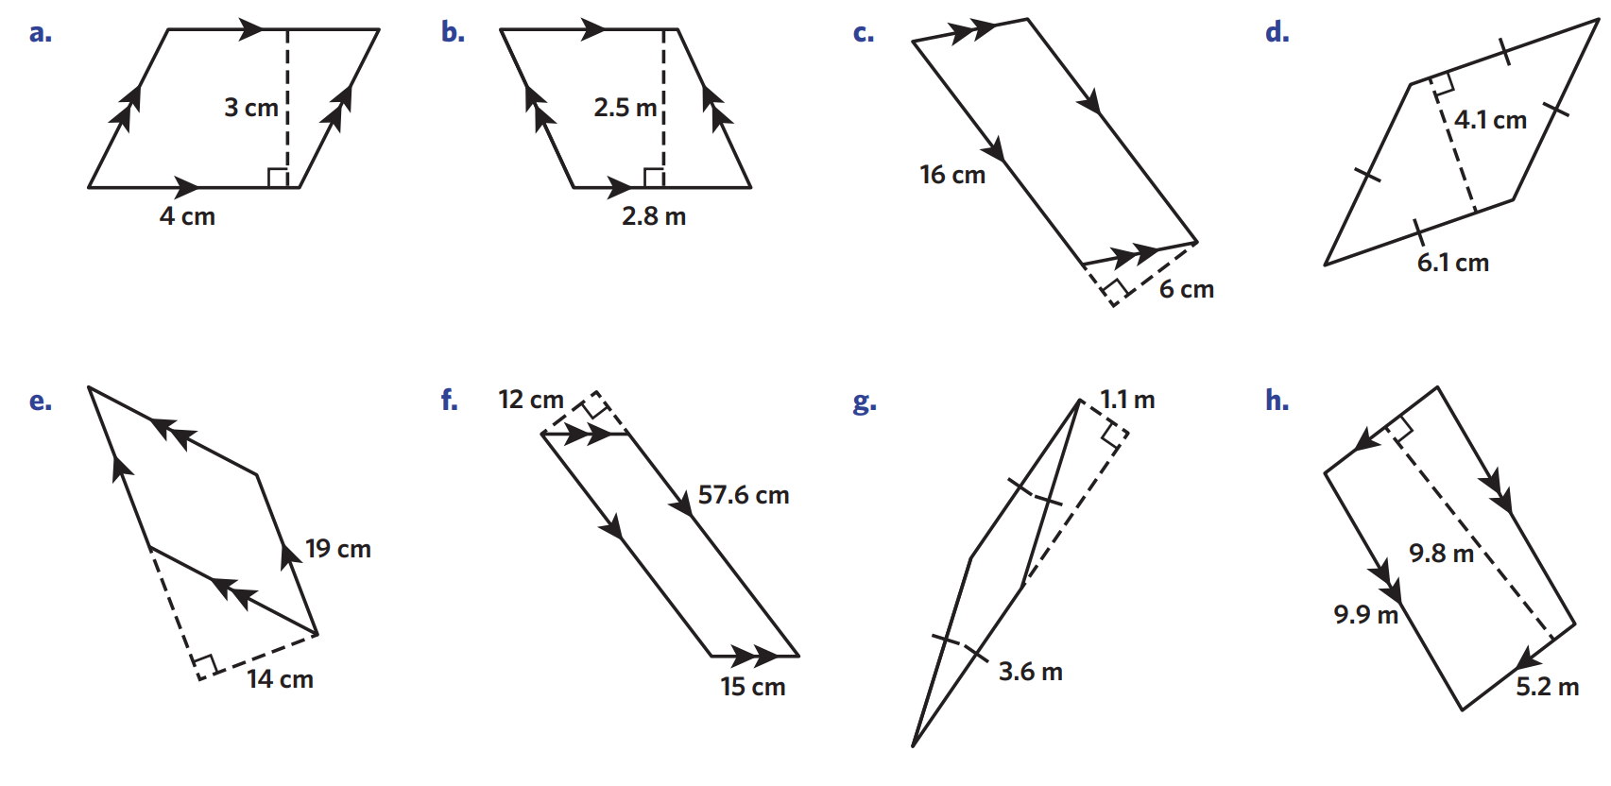  - Parallelogram  $A=bh$  $=( )( )$  $=$ …………  12 cm² | 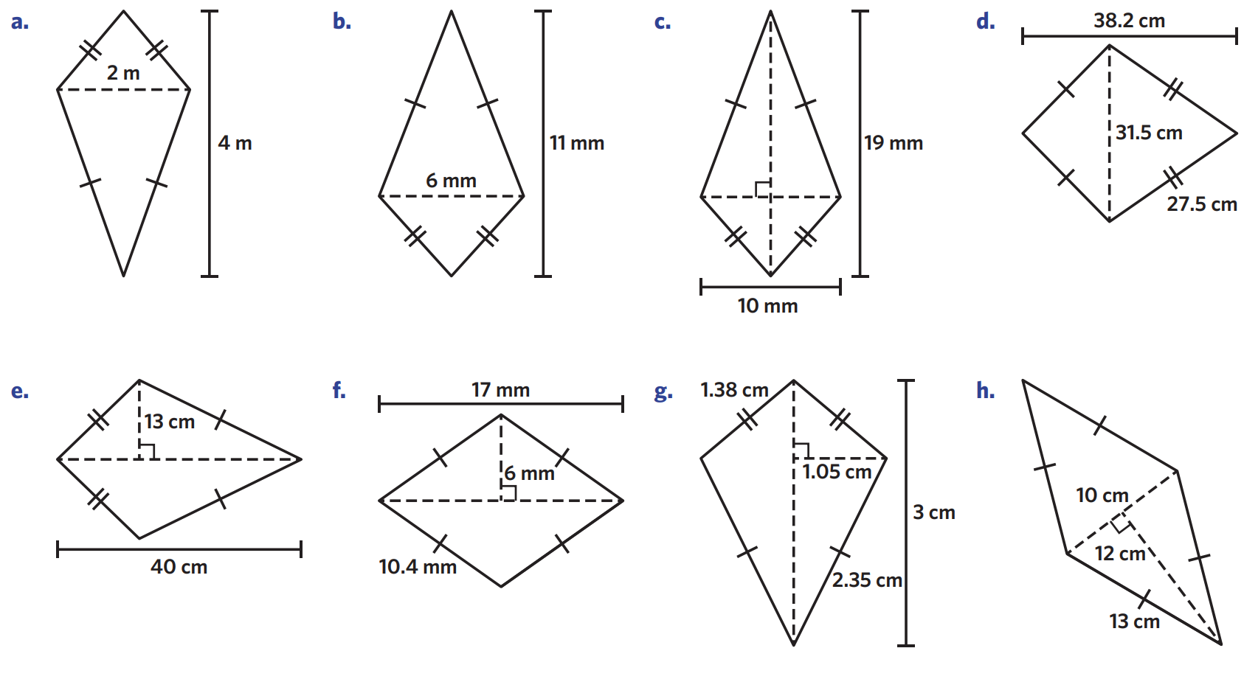  - Kite  $A=$ $\frac{xy}{2}$  $=$ $\frac{( )( )}{2}$  $=$ …………  4 m² | 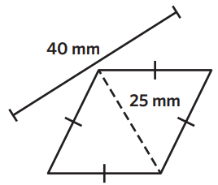  - Rhombus  $A=$ $\frac{xy}{2}$  $=$ $\frac{( )( )}{2}$  $=$ …………  500 mm²
95 mm² | 7 m² | 25.01 cm²
96 cm² | 3.96 m² | 601.65 cm²

- Explain why the area of this rhombus is NOT $\frac{8×10}{2}$
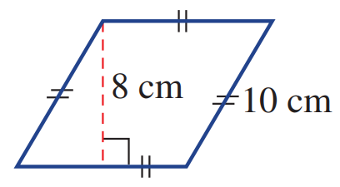

The diagonals are not 8 and 10. For this rhombus, we should consider it a parallelogram and use $A = bh$

Development
- Calculate the area of these shapes.
520 cm² | 102 cm² | 3.15 cm²
120 cm² | 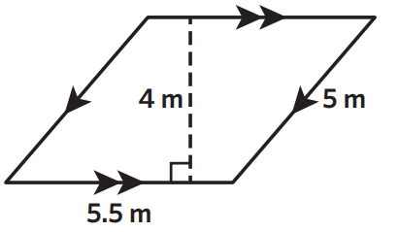  22 m² | 50.96 m²

- A flying kite is made from four centre rods all connected near the middle of the kite, as shown. What area of plastic, in square centimetres, is needed to cover the kite?
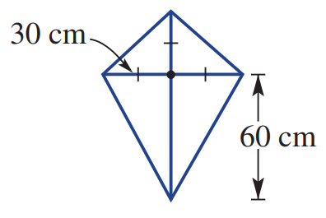

2700 cm²
- Explain why these two rhombuses have different areas.
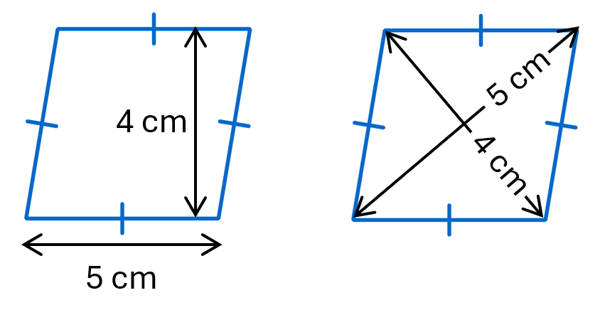

The first shape gives you the base and height, the second gives you the diagonals.

Area of a Trapezium

- Review
- Evaluate expressions with fractions
- $\frac{4(3+9)}{2}$ | - $\frac{6(3+11)}{2}$ | - $\frac{5(4+8)}{2}$

- Trapezium
A trapezium is a quadrilateral with one pair of parallel sides.
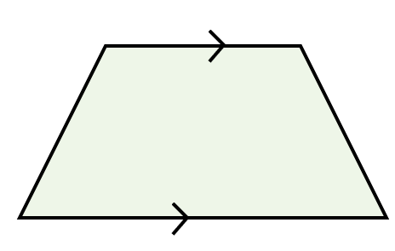

- Identify sides of a trapezium
The height of a trapezium is the perpendicular (at 90°) distance between the parallel sides.
Label the parallel sides $a$ and $b$, and draw the perpendicular height $h$.

- Key Ideas
- A trapezium is a quadrilateral with ……… pair of …………………… sides.

- Investigation area of a trapezium
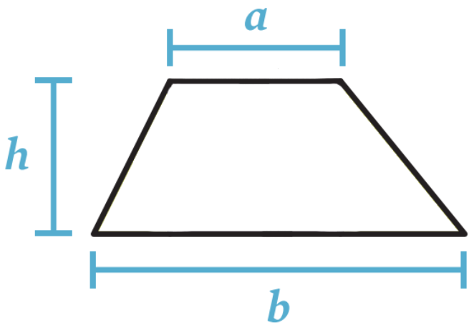
A trapezium is shown below. We’ll copy the trapezium and put two of them together.
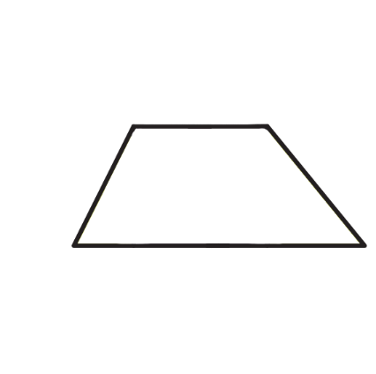

What shape do two trapeziums make?

By labelling the base and height of parallelogram, calculate the area of two trapeziums.

Therefore, what is the area of a trapezium?

- Area of a Trapezium
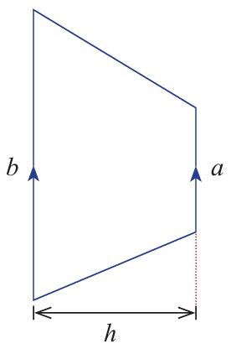
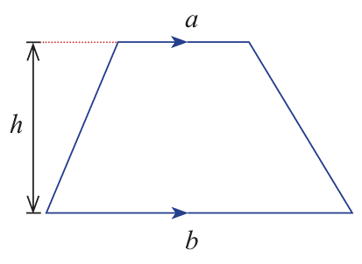
perpendicular
height parallel sides

$$A=\frac{h(a+b)}{2}$$

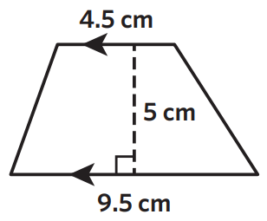
- Example Calculate area of a trapezium
$$A=\frac{h(a+b)}{2}$$  $$=\frac{5(4.5+9.5)}{2}$$  $=35$ cm² | $a$ and $b$ are the …………… sides of a trapezium.  $h$ is the ………………… distance between the parallel sides.

- Guided Practice
Calculate the area of these trapeziums.
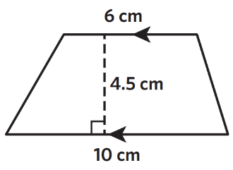  $$A=\frac{h(a+b)}{2}$$  $=$ ……………………  $=$ ……………………  36 cm² | 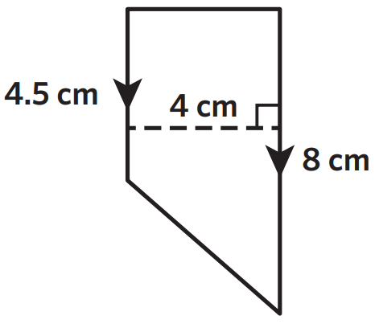  $$A=\frac{h(a+b)}{2}$$  $=$ ……………………  $=$ ……………………  25 cm²
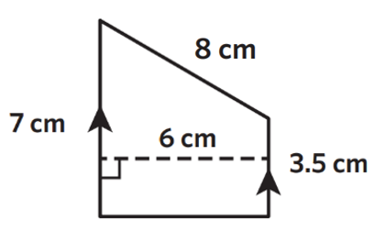  31.5 cm² | 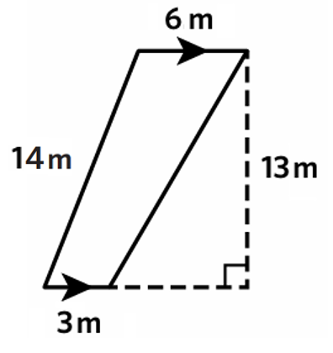  58.5 cm²

- Key Ideas
- The area of a trapezium is $A=$ $\frac{h(a+b)}{2}$, where $a$ and $b$ are the ……………… sides, and $h$ is the …………………… distance between them.

Foundation
- Calculate the area of these trapeziums.
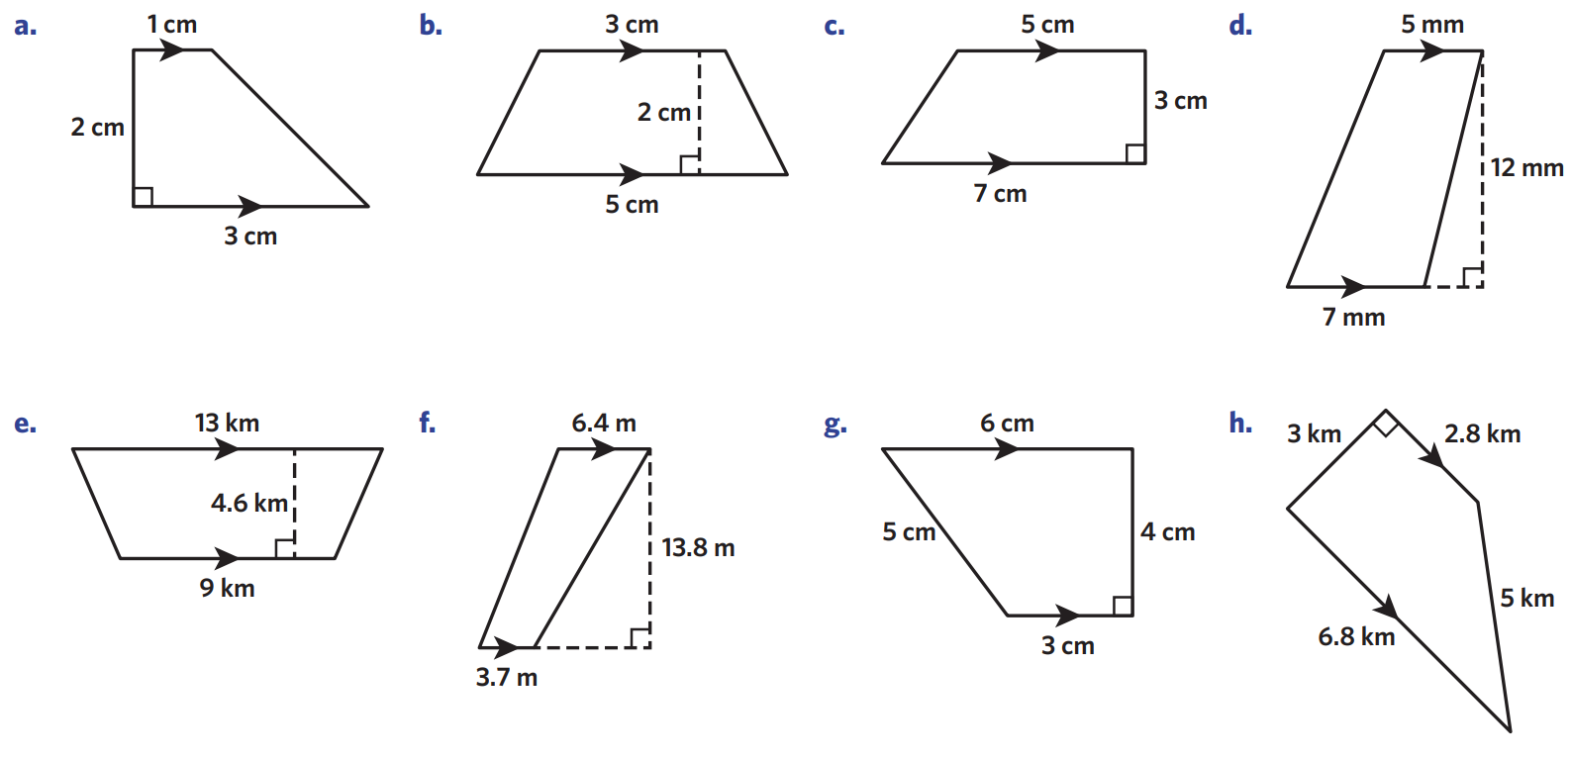  $$A=\frac{h(a+b)}{2}$$  $=$ ……………………  $=$ ……………………  4 cm² | 8 cm² | 72 cm²

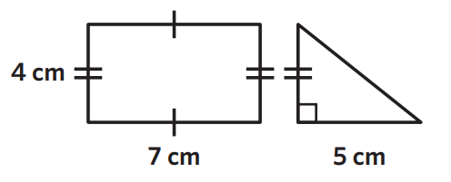  - Calculate the area of the rectangle and triangle.  $$4×7+\frac{1}{2}\left(4\right)\left(5\right)=38 {cm}^{2}$$ | 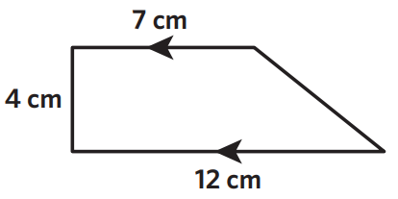  - Calculate the area of the trapezium using the formula.  $$\frac{4}{2}\left(7+12\right)=38 {cm}^{2}$$
  - What do you notice?

They are the same.
- Calculate the area of these trapeziums.
18 cm² | 14.4 km²
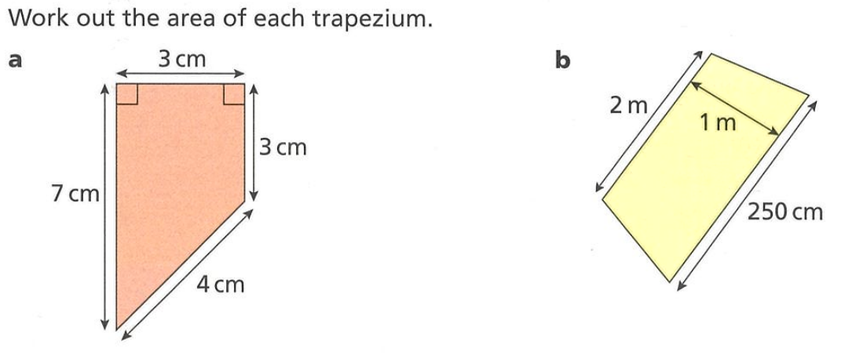  15 cm² | 2.25 m²

Development
- Identify the special quadrilateral as a parallelogram, rhombus, trapezium, or kite.
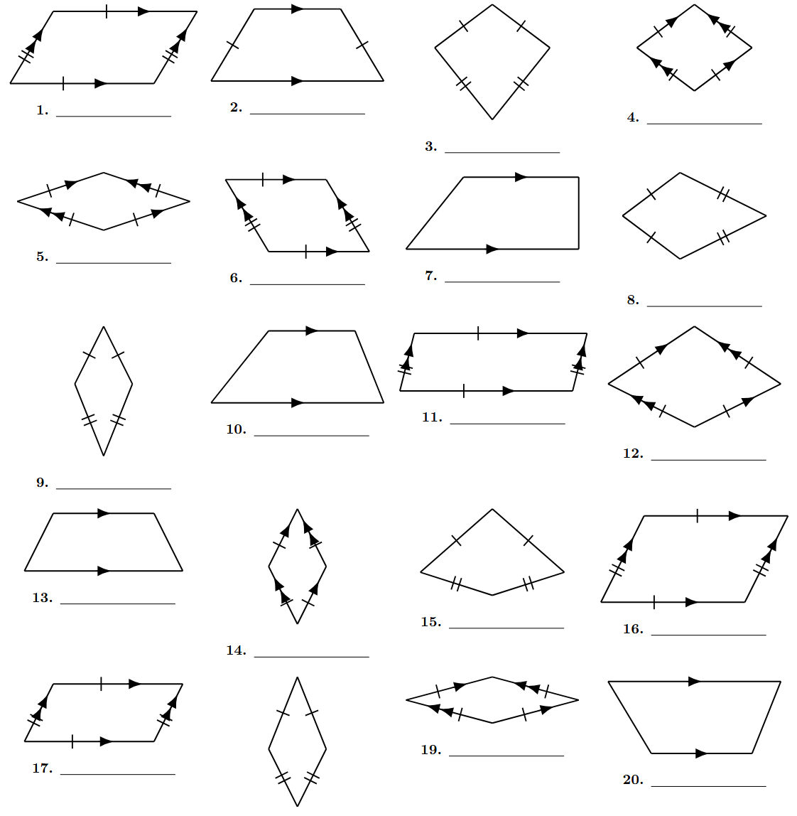  parallelogram | trapezium | kite | rhombus
rhombus | parallelogram | trapezium | kite
kite | trapezium | parallelogram | rhombus
trapezium | rhombus | kite | parallelogram
parallelogram | kite | rhombus | trapezium

- Identify the special quadrilateral then calculate the area of each special quadrilateral.
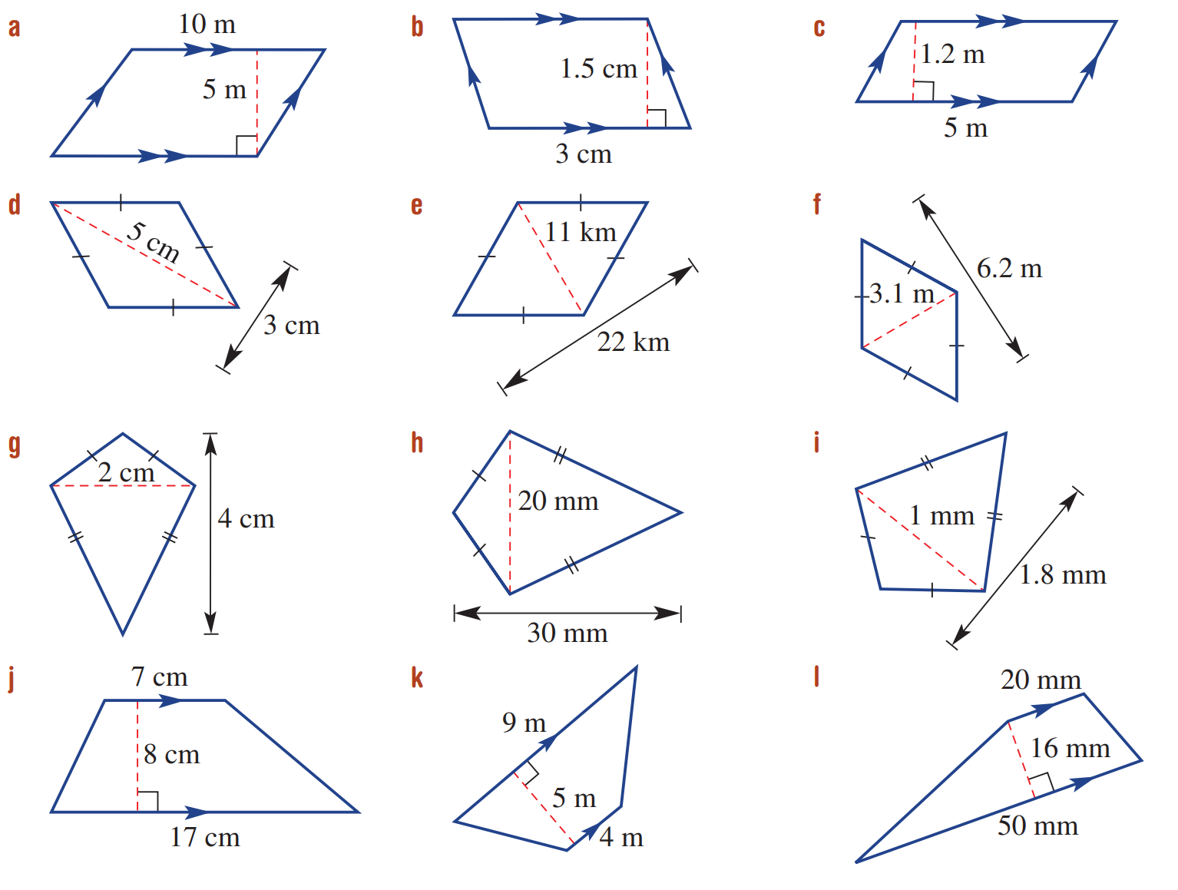  Parallelogram  $A=bh$  $=$  50 m² | 9.61 m² | 560 mm²
7.5 cm² | 32.5 m² | 4.5 cm²
96 cm² | 300 mm² | 0.9 mm²
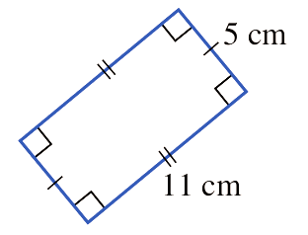  55 cm² | 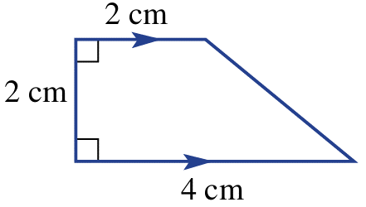  6 cm² | 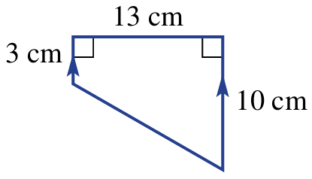  84.5 cm²

Mastery
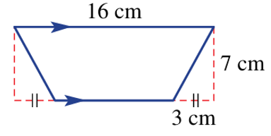
- Find the area of this trapezium.

91 cm²
- Read the worked example and answer the questions.
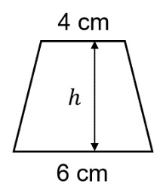  - The area of the trapezium is 15 cm².  Find the height.  $$A=\frac{h\left(a+b\right)}{2} \\ 15=\frac{h\left(4+6\right)}{2} \\ 15=\frac{10h}{2} \\ ×2=×2 \\ 30=10h \\ ÷10=÷10 \\ 3=h$$ | 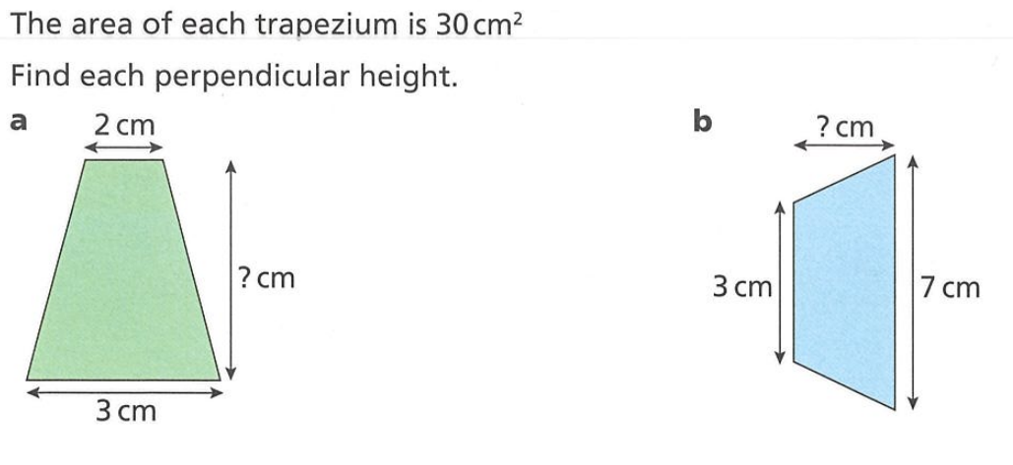  - The area of the trapezium is 30 cm²  Find the height.  12 cm | - The area of the trapezium is 45 cm²  Find the height.  9 cm

- Work out the length of each unknown side, if the area is 210 cm².
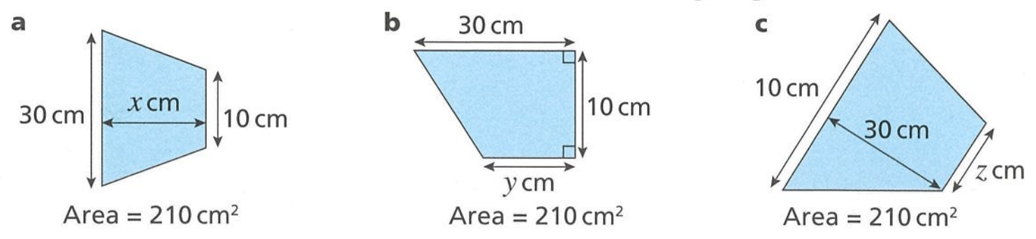  10.5 cm | 12 cm | 4 cm

- A trapezium has area 40 cm².  Its parallel sides are 7cm and 3 cm long. Find the height of the trapezium.  8 cm | - A trapezium with area 40cm² has one parallel side 10 cm long and height 5 cm. Find the length of the other parallel side.  6 cm

- Using the diagram and your knowledge of the area of composite figures,
derive the area of a trapezium by splitting a trapezium up into a rectangle and triangles.
 | $A_{1}=$ ………………  $$ah$$ | 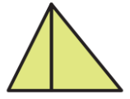  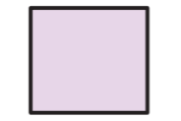  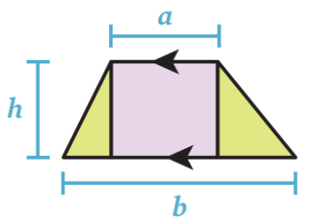  $A_{2}=$ ………………  $$\frac{h}{2}\left(b-a\right)$$ | $A=$ $A_{1} + A_{2}$  $=$  $$=ah+\frac{h}{2}\left(b-a\right)$$  $$=ah+\frac{bh}{2}-\frac{ah}{2}$$  $$=\frac{ah}{2}+\frac{bh}{2}$$  $$=\frac{h}{2}\left(a+b\right)$$

- Consider a ‘trapezium’ with $a=0, b=5$ and $h=3$. With all measurements in centimetres.
  - Calculate the area using the formula.
$$A=\frac{3(0+5)}{2}=7.5 {cm}^{2}$$
  - Sketch a diagram of this ‘trapezium’, what shape is it?

A triangle
  - Does this result match if you use the area formula for a triangle?

$$Yes, A=\frac{bh}{2}=\frac{3(5)}{2}$$
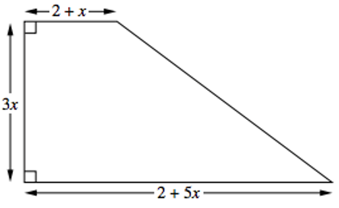
- A lawn is to be made in the shape shown.
Show that the area of the lawn is $A=9x^{2}+6x$

$$A=\frac{3x}{2}\left(2+x+2+5x\right)$$
$$=\frac{3x}{2}\left(4+6x\right)$$
$$=6x+9x^{2}$$

Area of Composite Figures with Special Quadrilaterals

- Example Calculate the area of composite figures involving quadrilaterals
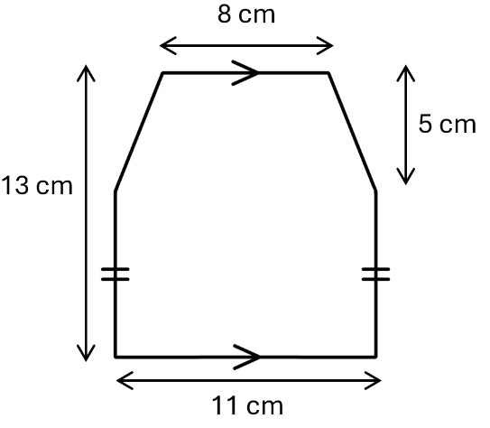
$$A_{2}$$
$$A_{1}$$

$$A_{1}=\frac{5(8+11)}{2}$$  $=47.5$ m² | $$A_{2}=8×11$$  $=88$ m² | $A_{Total}=47.5+88$  $=135.5 m^{2}$

- Guided Practice
Calculate the area of these composite figures.
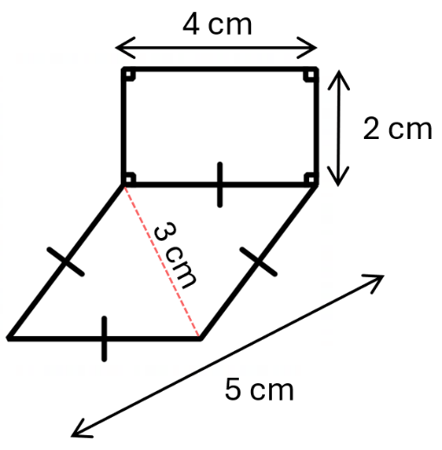  $A_{1}=$  $A_{2}=$  $A_{Total}=$  15.5 cm² | 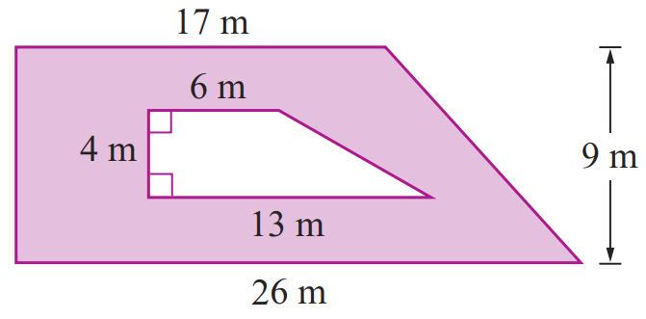  $A_{1}=$  $A_{2}=$  $A_{Total}=$  155.5 m²

Foundation
- Calculate the area of these composite figures. Round your answer to 2 d.p. where appropriate.
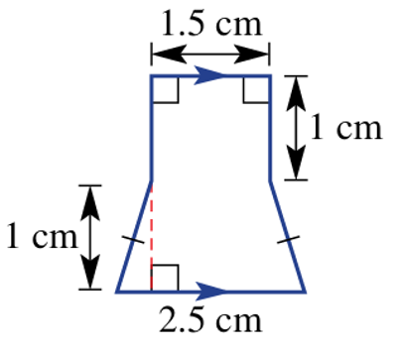  3.5 cm² | 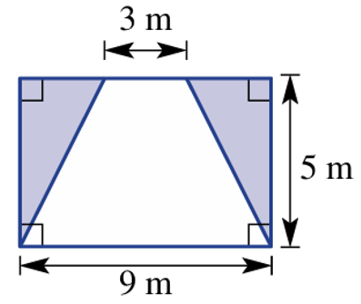  - Find the shaded area  15 m² | 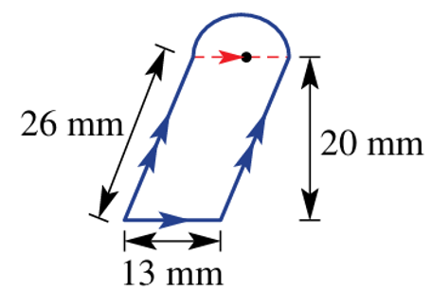  326.37 mm²
- Find the shaded area  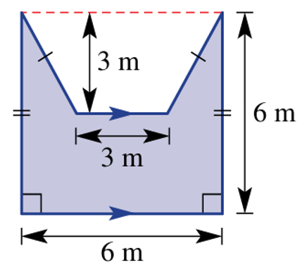  22.5 m² | 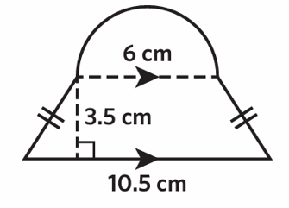  43.01 cm² | 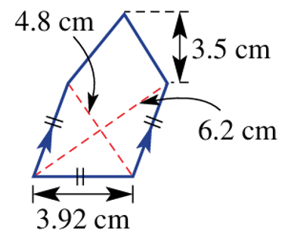  21.74 cm²
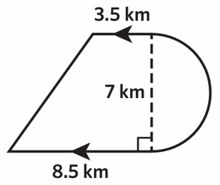  61.24 km² | 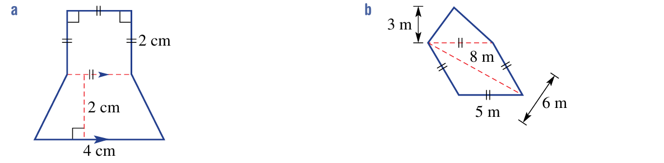  10 cm² | 31.5 cm²

Development
- Jakub and Marta are discussing how they found the area of the shape.
  - They have drawn how they plan to split up the shape. Use their methods to find the area.
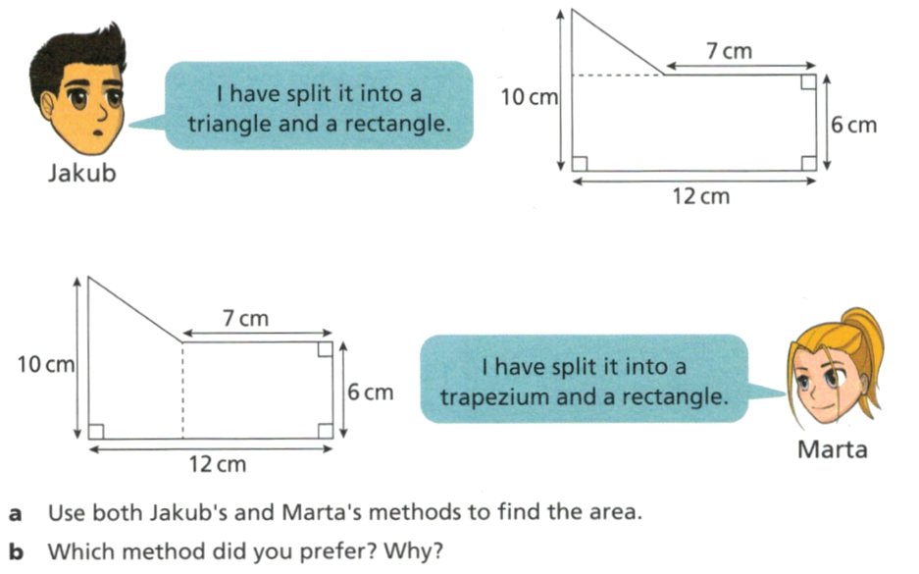  $$6×12+\frac{4×5}{2}=82 cm^{2}$$ | $$7×6+\frac{5}{2}\left(10+6\right)=82 {cm}^{2}$$
  - Which method do you prefer?

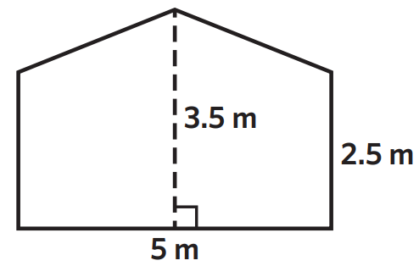
- Mark is planning to paint the side of his barn. He has measured it to be 5 m wide,
while the right and left sides are both 2.5 m high.
The barn reaches 3.5 m at its highest point perpendicular to the ground.
How many square metres does he need to paint?

15 m²
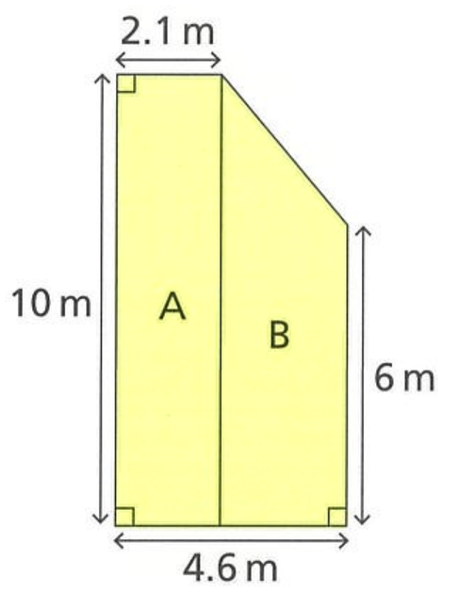
- The diagram shows the cross-section of a squash court. Find the area of the cross-section.

$$10×2.1+\frac{2.5}{2}\left(10+6\right)$$
$=41$ m²
- Find the area of the composite shapes.
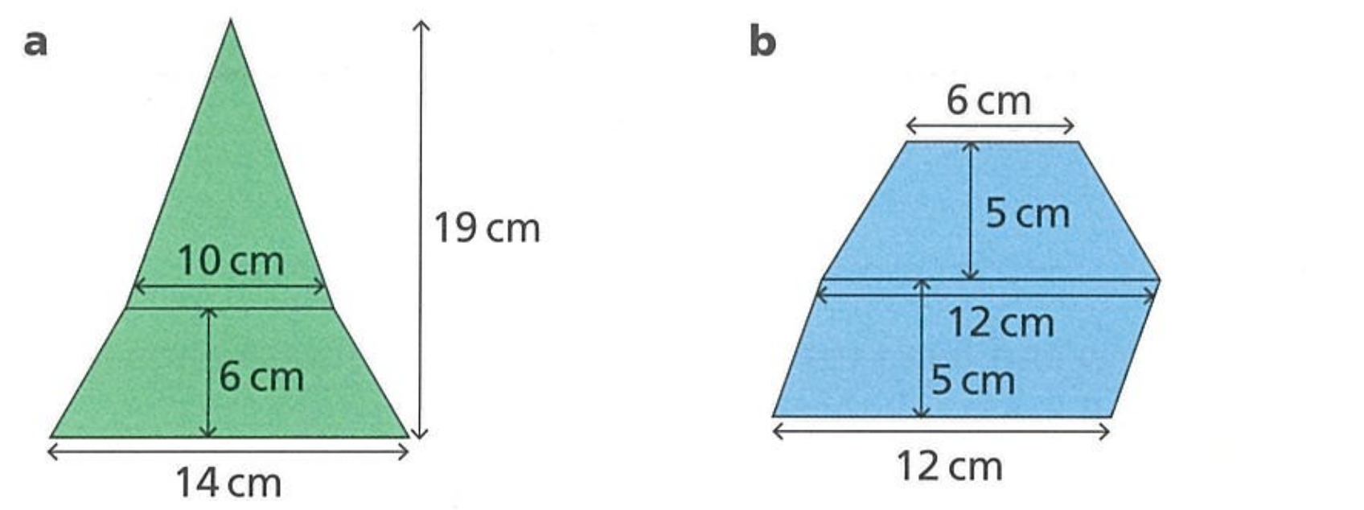  137 cm² | 105 cm²

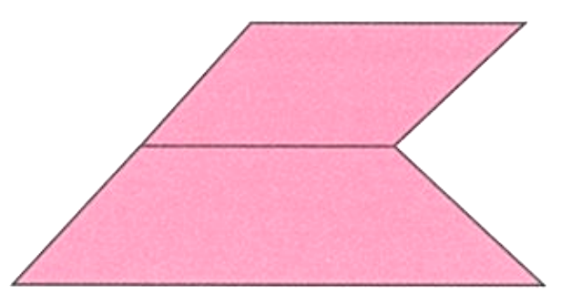
- A logo consists of a parallelogram on top of a trapezium, as shown.
The parallelogram has height 16 mm and base 32 mm.
The trapezium is the same height as the parallelogram and its base is twice the length of its top. Find the area of the logo, in square millimetres.

1280 mm²
- Calculate the area of this hexagon.
6 cm
10.4 cm
12 cm

Consider as two trapeziums
$$\frac{5.2}{2}\left(6+12\right)×2=93.6 cm^{2}$$
Check your answer by calculating the area
in a different way.

Another possibility is rectangle + 2 triangles

Mastery
- Calculate the shaded area of these shapes.
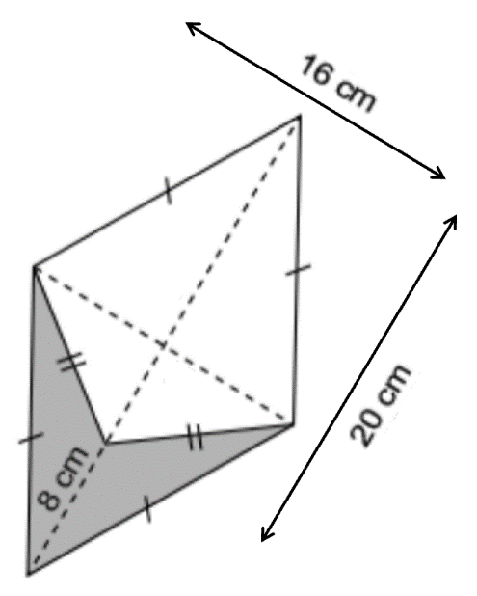  64 cm² | 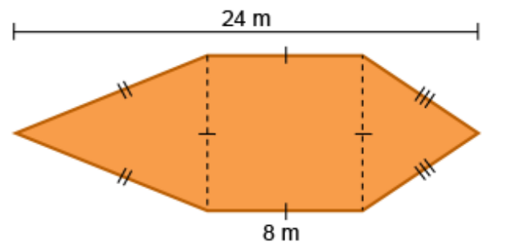  128 m² | 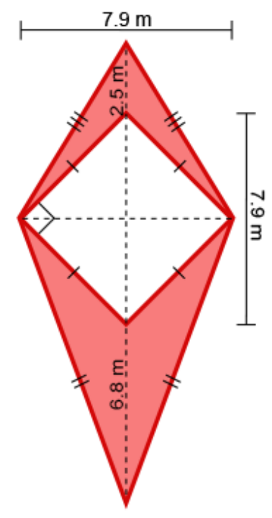  36.735 m²

- The front of a grandfather clock consists of a timber board with dimensions as shown.
A circle of radius 20 cm is cut from the board to form the clock face.
Find the remaining area of the timber board correct to one decimal place.
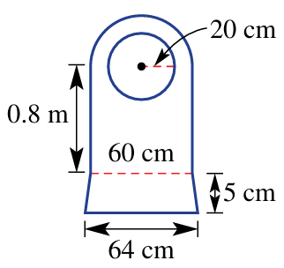

$$A_{Bottom trapezium}=\frac{5\left(64+60\right)}{2}$$
$$A_{middle rectangle}=80×60$$
$$A_{Top semicircle}=\frac{π{\left(30\right)}^{2}}{2}$$
$$A_{hole}=π{\left(20\right)}^{2}$$

Total area = 5267.1 cm²

Area Problems involving Pythagoras’ Theorem

Foundation
- Use Pythagoras’ theorem to calculate the missing length, then find the area.
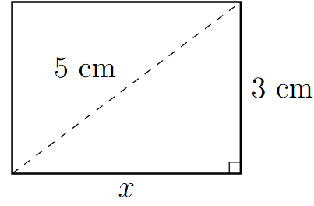  $$x=4$$  $A=12$ cm² | 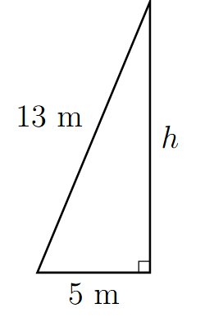  $$h=12$$  $A=30$ m²
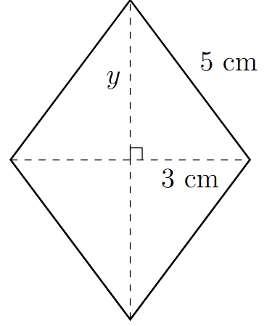  $$y=4$$  $A=24$ cm² | 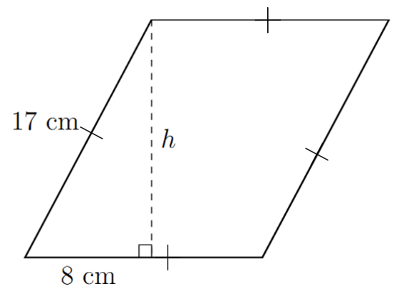  $$h=15$$  $A=255$ cm²
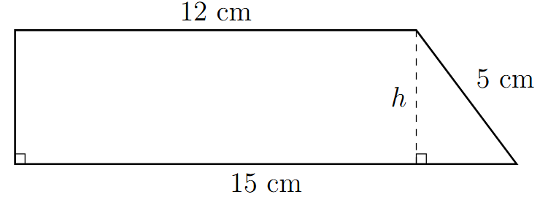  $h=4$ cm  $A=54$ cm² | 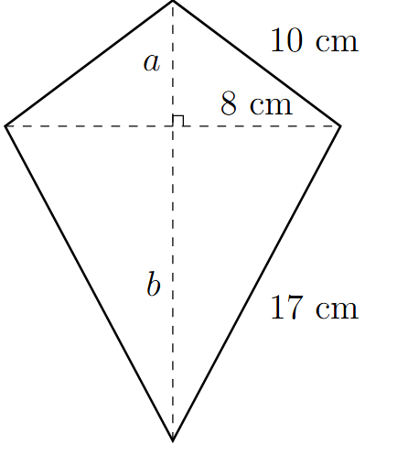  $$a=6$$  $$b=15$$  $A=168$ cm²
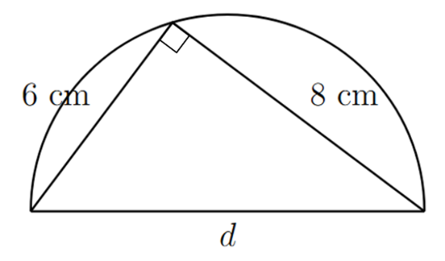  $$d=10$$  $A=25π$ cm² | 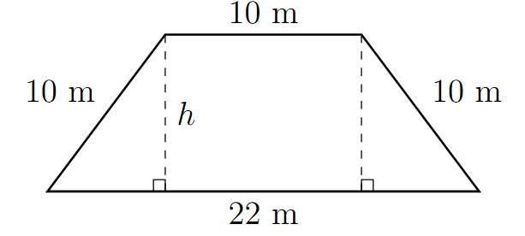  $$h=8$$  $A=128$ m²
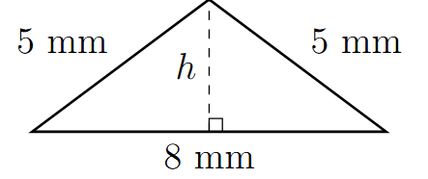  $$h=3$$  $A=12$ mm² | 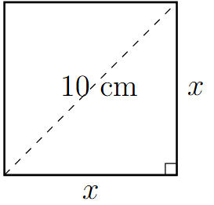  $$x=\sqrt{50}$$  $A=50$ cm²
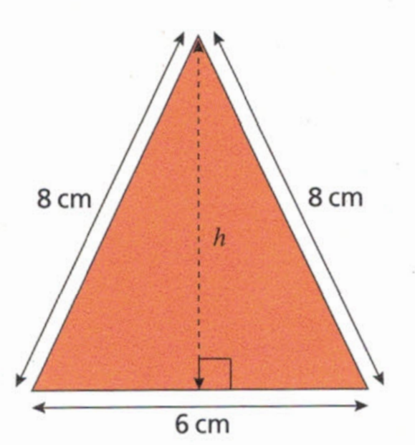
- Find the perpendicular height, $h$, of this isosceles triangle, then calculate the area to 2 d.p.

$$h=\sqrt{8^{2}-3^{2}}=\sqrt{55}$$
$$A=\frac{6×\sqrt{55}}{2}=22.25 {cm}^{2}$$
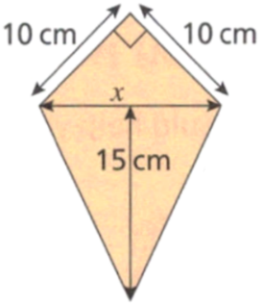
- Calculate $x$ and hence find the area of the kite. Round your answer to 2 d.p.

$$x=\sqrt{{10}^{2}+{10}^{2}}=\sqrt{200}$$
$$A=\frac{10×10}{2}+\frac{15×\sqrt{200}}{2}=156.07 {cm}^{2}$$
- A square has a diagonal of length 20 cm.
- Determine its area using Pythagoras’ Theorem  Let side length be $x$  $$x^{2}+x^{2}={20}^{2}$$  $$2x^{2}=400$$  $$x^{2}=200$$  $∴$ Area is 200 cm² | - This is Aiden’s solution.  Explain why it works.  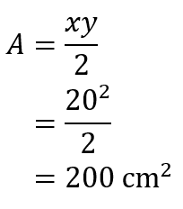  A square is also a rhombus.

- A square of side length 14 cm is inscribed inside a circle as shown.
Find the area of the circle in exact form.
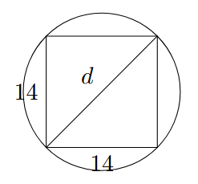

$$d=\sqrt{392}$$
$$A=π{\left(\frac{\sqrt{392}}{4}\right)}^{2}$$
$$=π\left(\frac{392}{4}\right)$$

$=98π$ cm²

Development
- Find the missing sides, then find the area. Round your answer to 1 d.p.
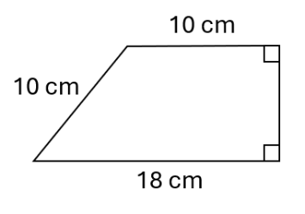  $$h=\sqrt{{10}^{2}-8^{2}}=6$$  $$A=\frac{6}{2}\left(10+18\right)=84 {cm}^{2}$$ | 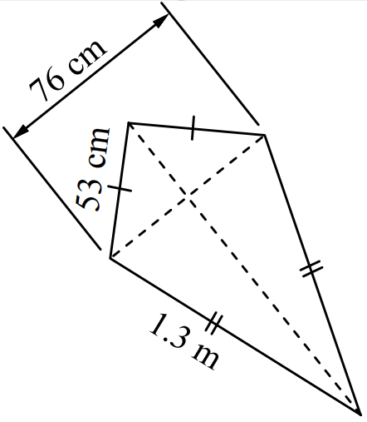  Other diagonal  $\sqrt{{53}^{2}-{38}^{2}}+\sqrt{{130}^{2}-{38}^{2}}=161.268$  $$A=\frac{161.268×76}{2}=6128.2 {cm}^{2}$$
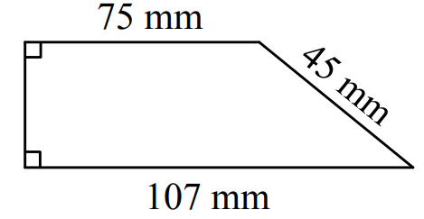  $$h=\sqrt{{45}^{2}-{32}^{2}}$$  $$h=\sqrt{1001}$$  $$A=\frac{\sqrt{1001}}{2}\left(75+107\right)=2879.1 {mm}^{2}$$ | 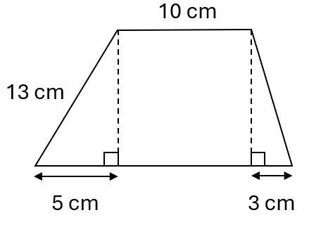  $$h=\sqrt{{13}^{2}-5^{2}}=12$$  $$A=\frac{12}{2}\left(10+18\right)=168 {cm}^{2}$$
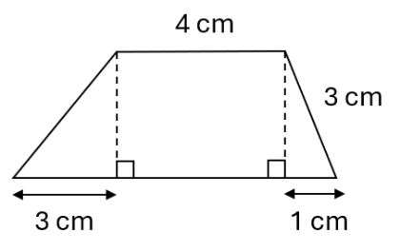  $$h=\sqrt{3^{2}-1^{2}}$$  $$h=\sqrt{8}$$  $$A=\frac{\sqrt{8}}{2}\left(8+4\right)=17.0 {cm}^{2}$$ | 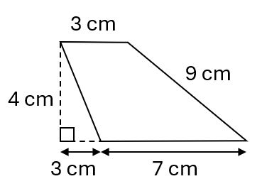  $$A=\frac{4}{2}\left(3+7\right)=20 {cm}^{2}$$

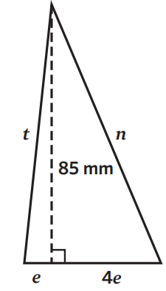
- Calculate the unknown values to 1 d.p., given the area of the triangle is 2550 mm²

$$2550=\frac{85×5e}{2}$$
$$2550=\frac{425}{2}e$$
$e=12$ mm
$t=\sqrt{{12}^{2}+{85}^{2}}=85.84$ cm
$n=97.62$ cm

Mastery

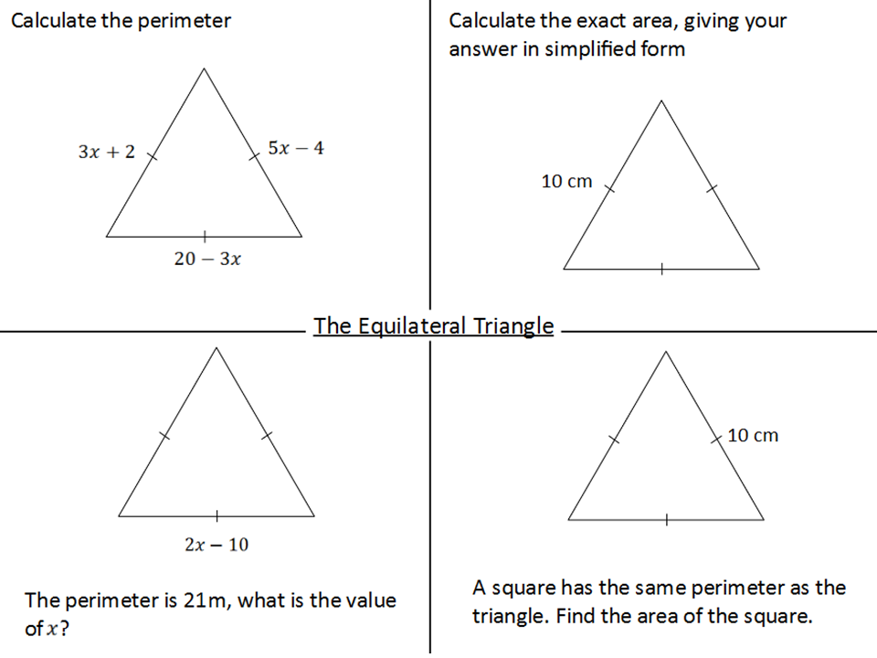  - Write an expression for the perimeter.  $$5x+18$$ | - Calculate the exact area of the triangle.  Height = $\sqrt{{10}^{2}-5^{2}}=\sqrt{75}$  $$A=\frac{1}{2}×10×\sqrt{75}=5\sqrt{75} {cm}^{2}$$  $$or 25\sqrt{3} {cm}^{2}$$
- If the perimeter is 21 m, what is the value of $x$?  $$6x-30=21$$  $$6x=51$$  $x=8.5$ cm | - A square has the same perimeter as the triangle. Find the area of the square.  Perimeter of square = 30 cm  Side length = $\frac{30}{4}$ $=7.5$ cm  Area of square = ${7.5}^{2}=56.25 {cm}^{2}$

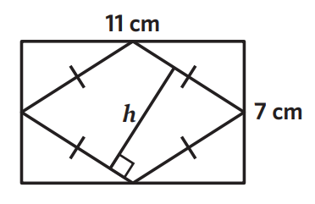
- A rhombus with a perimeter of 26 cm sits inside a rectangle with side lengths 11 cm and 7 cm. The vertices of the rhombus are at the midpoints of the sides of the rectangle.
Determine the length of $h$, rounded to 2 decimal places.

Area of Rhombus = $\frac{11×7}{2}$ $=38.5 {cm}^{2}$
Base $=\sqrt{{3.5}^{2}+{5.5}^{2}}=6.519202405$
$$A=bh$$
$$38.5=6.519202405h$$
$$h≈5.91 cm$$

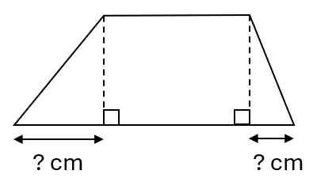
- The area of the trapezium is 294 cm².
The height of the trapezium is three-fifths of the left leg and 1 cm less than the right leg.
If the parallel sides are 14 cm and 35 cm, find the missing sides.

$$294=\frac{h}{2}\left(14+35\right)$$
Height is 12 cm
Left leg is 20 cm, right leg is 13 cm
Using Pythagoras, missing lengths are 16 cm and 5 cm

